**La endoscopia**

**Investigación sobre la endoscopia y sus beneficios**

**F13 REC230**

**Imagen 1**

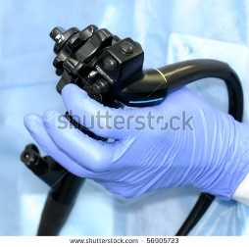 [56905723](http://www.shutterstock.com/pic-56905723/stock-photo-hand-of-doctor-managing-modern-endoscope.html?src=pp-photo-228534661-NVyxunk5y0_ZqzCGc0hH_A-4)

Imagen 2

 [168325589](http://www.shutterstock.com/pic-168325589/stock-photo-endoscope-examination.html?src=pp-photo-228534661-NVyxunk5y0_ZqzCGc0hH_A-7)

Imagen 3

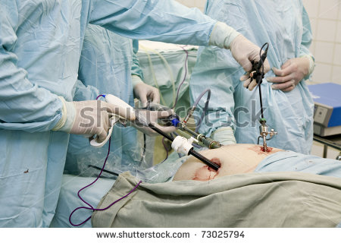 73025794

Imagen 4

 [72550087](http://www.shutterstock.com/pic-72550087/stock-photo-conference-center.html?src=zYEJTPb1gr5tylJTJvga1A-1-60)